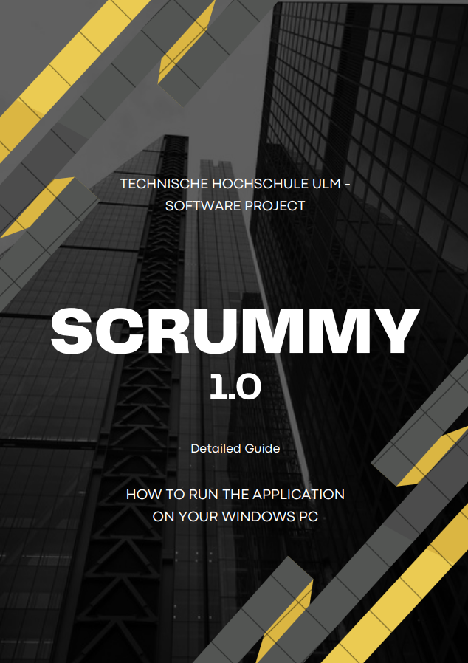

**Disclaimer**

This software was created by a group of 8 people, with intentions of only achieving a high grade at a university course. There is no purpose of our team to sell this software  
Most of the content in this document is created from scratch, though the things for example, pictures or information that were taken from various websites are referenced at the last page of this document, to respect the copyrights policies.

If you have any questions regarding the build process, please reach me out on my email:

aqeemu01@thu.de

Department of Computer Science Technische Hochschule Ulm  
Germany

**Steps to run the code on your PC:**

**Required Steps for having a successful build:**

1. QT 6.6.0
2. MySQL – Drivers
3. Python Drivers
4. Steps for creating the build

**STEP 1:**

QT 6.6.0

* 1. First you need to create an account to get a license from the QT company providers, if your university is recognized on there system, then for students you can access the product for free for a limited time. Link to their registration forum:  
     [Try Qt | Develop Applications and Embedded Systems | Qt](https://www.qt.io/download#eval-form-modal)
  2. After creating an account, you will can either download their Maintenance tool or from this link download this specific version of QT which is version 6.6.0, as our MSQL-Drivers provided on Git is version specific  
     1. Using the Maintenance tool  
        A screenshot of a computer program

        Description automatically generated
     2. Using the old achieve files from QT Official Website:  
        [Index of /archive/qt/6.6/6.6.0/single](https://download.qt.io/archive/qt/6.6/6.6.0/single/)
  3. Make sure to note down your installation path that you decided on your PC, as later we need to add a few files in some folders

**STEP 2:**

MY-SQL Drivers

1. Download this folder from our Git Repo:  
   [muazzamaqeel/softwareproject: Scrummy (github.com)](https://github.com/muazzamaqeel/softwareproject)
2. Copy all the files in the following folders separately in your QT installation directory
   1. QT_InstallationFiles\6.6.0\mingw_64\lib
   2. QT_InstallationFiles\6.6.0\mingw_64\bin
   3. QT_InstallationFiles\6.6.0\mingw_64
   4. QT_InstallationFiles\6.6.0\mingw_64\plugins
   5. QT_InstallationFiles\6.6.0\mingw_64\plugins\sqldrivers

For example: This is how you need to copy all those files to all of the required folders indicated in the 2nd point above  
  
**QT_InstallationFiles\6.6.0\mingw_64\plugins\sqldrivers**

**STEP 3:**

Python Drivers

1. For some user if they have not installed any python based applications on their system, then they just need to one additional step to make sure that the build process executes seamlessly  
   1. From the following website or the missing .dll file is also available on our repo:  
      Website link: [python312.dll : Free .DLL Download. - DLLme.com](https://www.dllme.com/dll/files/python312)  
      Repo Link:

Below you can see from a screenshot where is the file located on the website, Please download the 64-Bit Version, if you have a 64-Bit based Operating System

**STEP 4:**

Creating the Build   
(Additional Steps Regarding Git are also explained here)

1. Once you have cloned the project on your PC, navigate to this folder  
   Path:
2. Now copy the path and open your QT Tool
   1. It will ask you to open a project to simply navigate to the top left side of the application and click file and then Open Project
   2. Paste the path and just double click on the following file that should exist in the project’s folder

Summary

You might find some alternative ways to build the project on your Windows based PC, these were the steps taken by almost every member in our team to execute the source code on their systems, to preform the further advancements of the project itself.

Team Members :  
Muazzam Bin Aqeel – (**Scrum Master** + Full Stack Developer)  
Wesley – (**Product Owner** + Full Stack Developer)

Aida Zhumiyeva – (**Quality Architect** + Front-End Developer)  
  
Cosmin – (**Software Architect** + Full Stack Developer)

Keti Hazbiu – (**Software Architect** + Full Stack Developer)

Ruth Jesulayomi Mautin Amosu – (**Software Architect** + Full Stack Developer)  
  
Ebtehal Aldheeshy – (**Software Architect** + Back-End Developer)  
Citlalin Reyes Soto – (**Software Architect** + Back-End Developer)

References